**Azure**

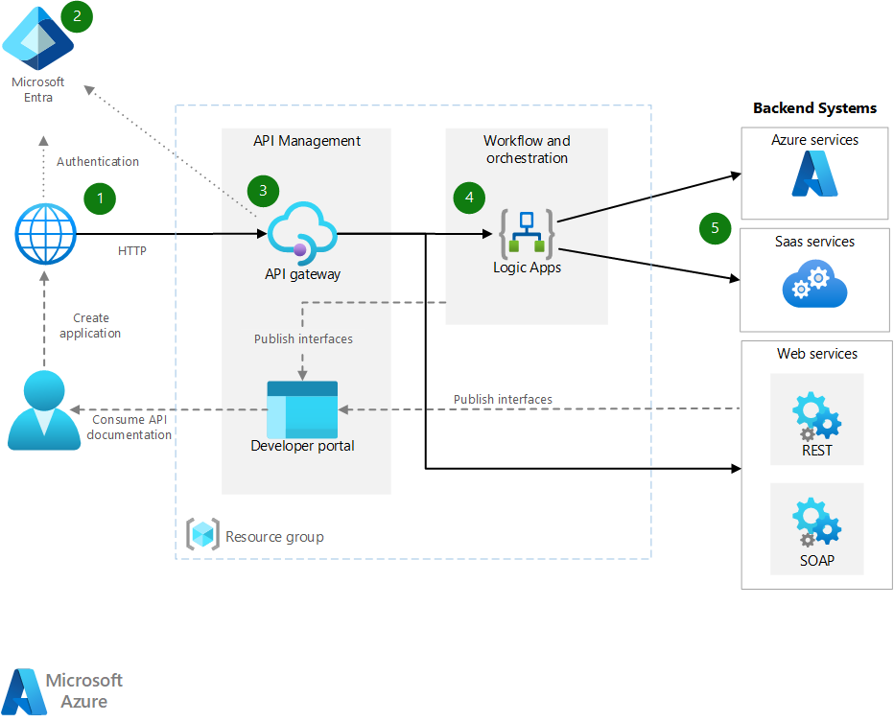

**Workflow**

1. **Application**. The application is a client that calls the API gateway after authenticating with Microsoft Entra. The application can be a web app, mobile app, or any other client that can make HTTP requests.
2. **Microsoft Entra ID**. Is used to authenticate the client application. The client application obtains an access token from Microsoft Entra ID and includes it in the request to the API gateway.
3. **Azure API Management**. API Management consists of two related components:
   * **API gateway**: The API gateway accepts HTTP call from the client application, validates the token from Microsoft Entra ID, and forwards the request to the backend service. The API gateway can also transform requests and responses, and cache responses.
   * **Developer portal** is used by developers to discover and interact with the APIs. The developer portal can be customized to match your organization's branding.
4. **Azure Logic Apps**. Logic apps are used to orchestrate the calls to the backend services. Logic apps can be triggered by a variety of events and can call a variety of services. In this solution, Logic Apps is used to call the backend services and provide easy connectivity through connectors reducing the need for custom code.
5. **Backend services**. The backend services can be any service or line of business application, such as a database, a web service, or a SaaS application. The backend services can be hosted in Azure or on-premises.

**Region**

1. A region is a geographical area containing at least one, but potentially multiple datacenters that are nearby and networked together with a **low-latency network.**
2. When one deploys a resource in Azure, one needs to choose the region where you want your resources deployed.
3. **Examples of regions** are West US, Canada Central, West Europe, Australia East, and Japan West.
4. To minimize network latency, put API Management and Logic Apps in the same region. In general, choose the region that's closest to your users.
5. Azure regions are made to provide both localized disaster protection with availability zones and regional or big geographic catastrophe protection with disaster recovery by utilizing another region.

Region Selection Criteria

* Customer base location to avoid latency.
* Service availability – preview, GA
* Compliance
* Pricing
* Redundancy

**Availability Zone**

1. Availability Zones are physically separate datacenters within an Azure region.
2. Each Availability Zone is made up of one or more data centers equipped with independent power, cooling, and networking. It is set up to be an *isolation boundary*.
3. Azure creates a duplicate of your data and resources so that the information is safe, in case of failure. If one zone goes down, the other continues working.
4. Resources are highly available through Availability Zones.
5. **Not every region has support for Availability Zones.** The **examples of Availability Zones** are Central US**,**East US 2, West US 2, West Europe, France Central, North Europe & Southeast Asia.

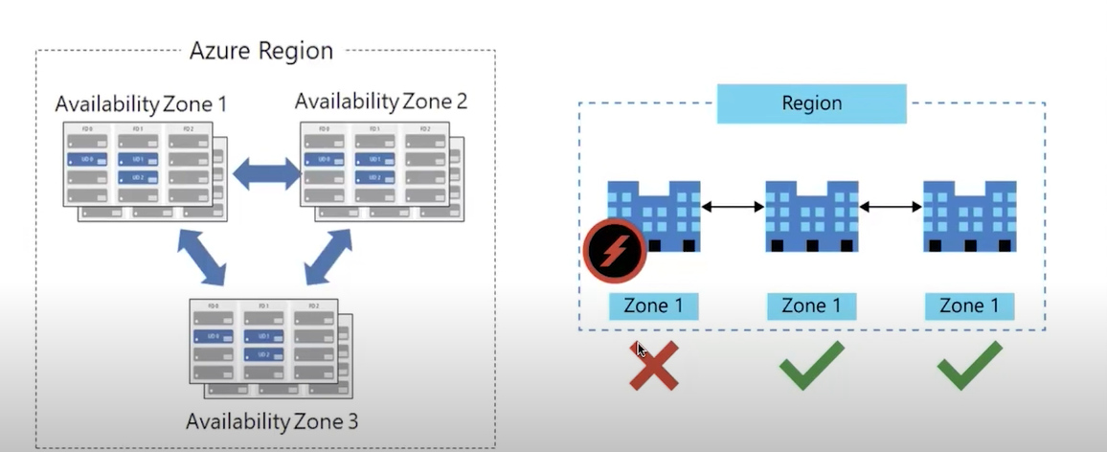

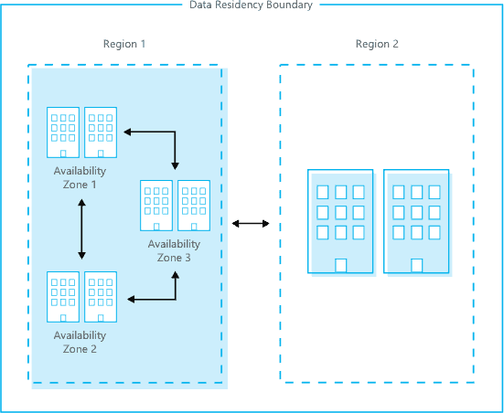

**Resources:**

Resources are instances of services that you create, like virtual machines, storage, or SQL databases.

**Resource groups:** (are like a folder)

**Resources are combined into resource groups**. Resource groups act as a logical container into which Azure resources like web apps, databases, and storage accounts are deployed and managed.

**Subscriptions:**

A subscription groups together user accounts and the resources that have been created by those user accounts. For each subscription, there are limits or quotas on the amount of resources that you can create and use. Organizations can use subscriptions to manage costs and the resources that are created by users, teams, or projects.

**Management groups:**

These groups help you manage access, policy, and compliance for multiple subscriptions. All subscriptions in a management group automatically inherit the conditions applied to the management group.

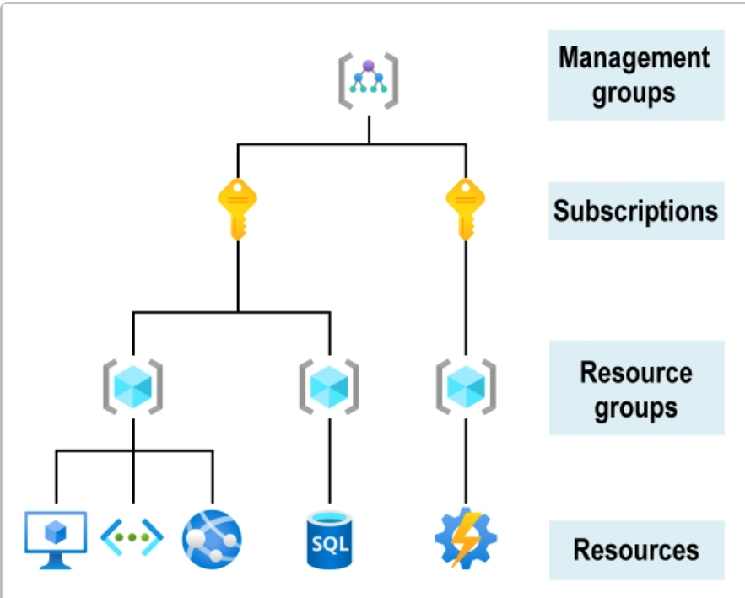

**Azure Resource Manager**

ARM is the deployment and management service for azure. It allows you to organize and manage resources like virtual machines, storage, and database in a unified, structured way.

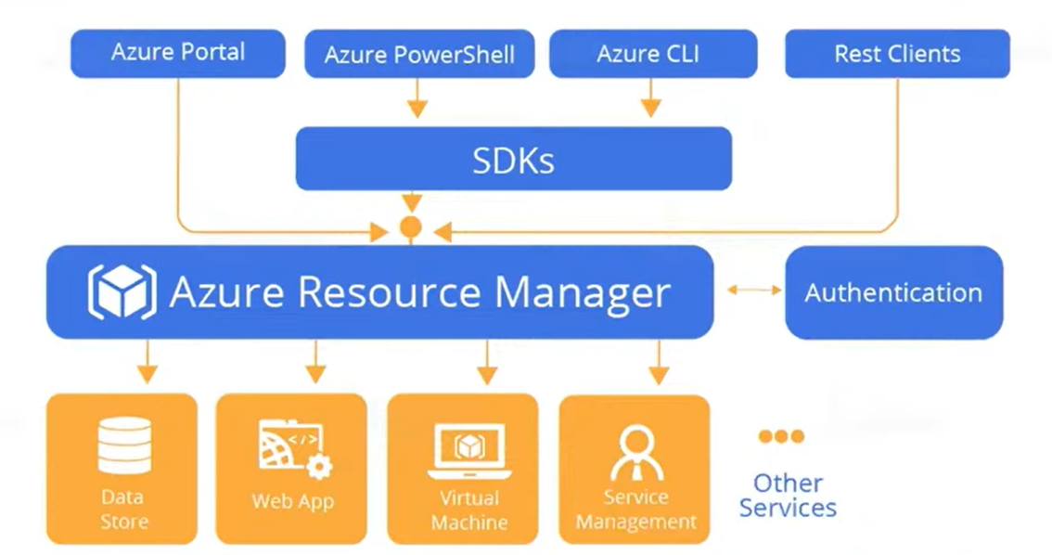

Resource Grouping: Organize related resources into resources groups.

Consistent management: manage resources via portal, cli, powershell, or template.

Role-based access control: secure access with permissions for team members.

Contralized control: manage all resource in one place.

Cost management: monitor and control costs by resource group.

Scalability: automate large-scale deployments easily.

Cloud

Cloud services are offered in different models depending on how much control and management responsibility the customer vs. provider has.

Iaas – (like a Virtual machine) azure will provide an infrastructure

**Infrastructure as a Service (IaaS)**

* Provides **virtualized computing resources** over the internet.
* Customer manages: OS, applications, middleware, runtime, data.
* Provider manages: hardware, storage, networking, virtualization.
* **Examples**:
  + Virtual Machines (Azure VMs)
  + Networking (Virtual Network, Load Balancer, VPN Gateway)

Paas – platform as a service

* Provides a **development and deployment environment** in the cloud.
* Customer manages only apps and data.
* Provider manages OS, runtime, scaling, infrastructure.
* **Examples**:
  + Azure App Services
  + Azure SQL Database
  + Azure Functions

Saas – software as a service

* Provides **ready-to-use applications** delivered over the internet.
* Everything is managed by the provider.
* Customers just use the software.
* **Examples**:
  + Microsoft 365
  + Dynamics 365
  + Salesforce

|  |  |  |  |
| --- | --- | --- | --- |
| **Feature** | **IaaS (Infrastructure)** | **PaaS (Platform)** | **SaaS (Software)** |
| **What you manage** | Apps, Data, Runtime, OS | Apps, Data | Just use the app |
| **What provider manages** | Hardware, Networking, Virtualization | Hardware, Networking, OS, Runtime | Everything (infra + app) |
| **Use case** | Migration of workloads, custom apps | Build, test, deploy apps quickly | Ready-to-use business apps |
| **Examples** | Azure VMs, Networking | Azure App Service, Azure SQL | Microsoft 365, Dynamics 365 |

**Azure Storage service**

**Azure Disk Storage:**

Storage on HDD or SSD for azure virtual machines.

**BLOB Storage:**

For storing massive amounts of unstructured data like text, images, audio/videos, document etc.

**Queue Storage:**

Storing large number of message; access message from anywhere in the world via authenticated calls using HTTP.

LRS – Locally Redudant Storage

Is a cheap policy

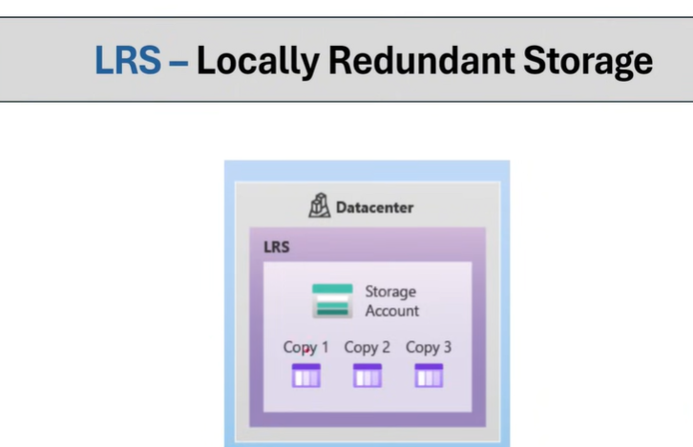

ZRS - Zone Redundant Storage

GRS

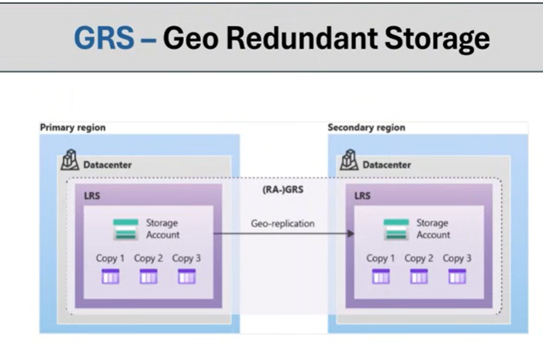

**Azure services:**

**Azure Compute Services**

Azure Compute services power your applications and workloads in the cloud. This includes Virtual Machines for scalable compute resources, Virtual Machine Scale Sets for automatic scaling, and Availability Sets for enhanced reliability.

* Virtual Machines
  + Single
  + Scale Set
  + Availability Set
* App Services
* Azure Container Service
* Azure Kubernetes Service
* Azure Functions (Serverless)
* Azure Virtual Desktop

**Compute service:**

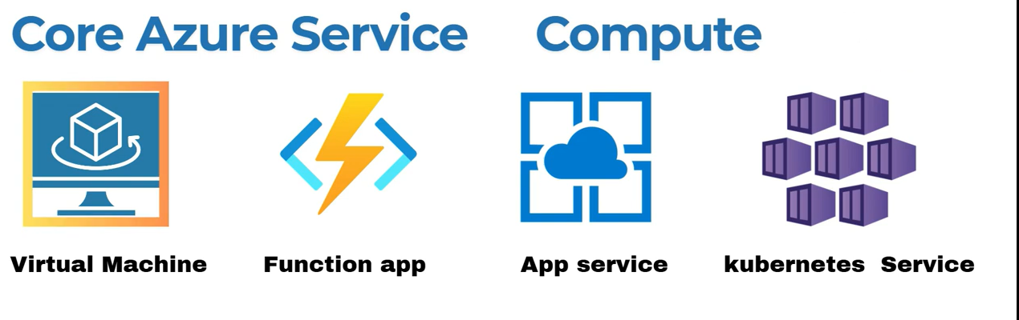

Virtual machine:

VM Is a scalable, on-demand computing resource that runs applications and operating system in the cloud. It functions like a physical computer but is managed virtually. VMS are commonly used for hosting websites, running applications, or testing environments without maintaining physical hardware.

VMs are used to create and configure virtualized operating systems and applications, making it possible to run multiple copies of multiple operating systems and applications on a single physical server.

VMs are used to host websites, applications, and databases, or to provide secure storage and remote access to corporate data.

Horizontal Scaling: - increasing the no. of server.

Vertical scaling: - increasing the configuration of your system (use are using the i3 service, traffic increases use i5 service).

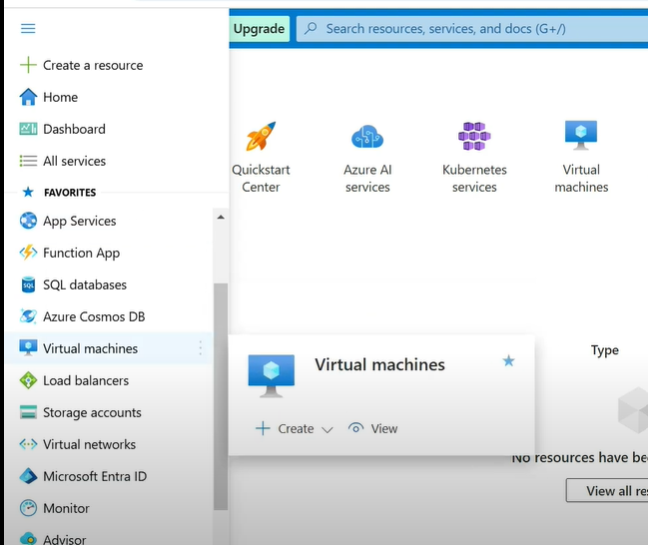

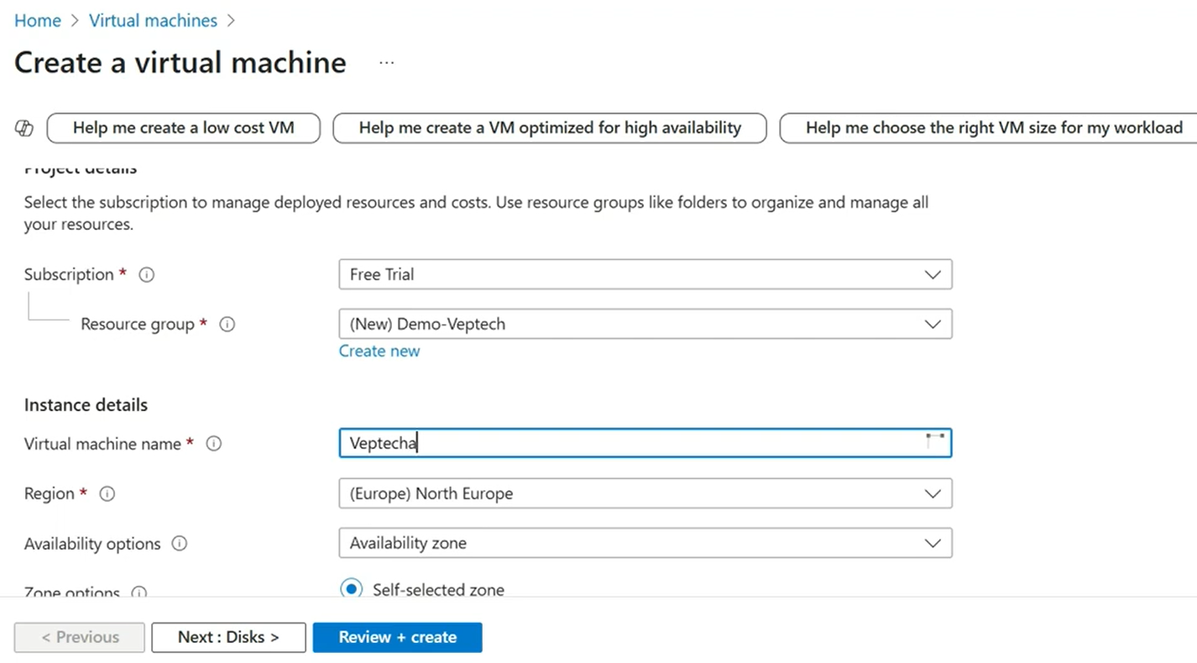

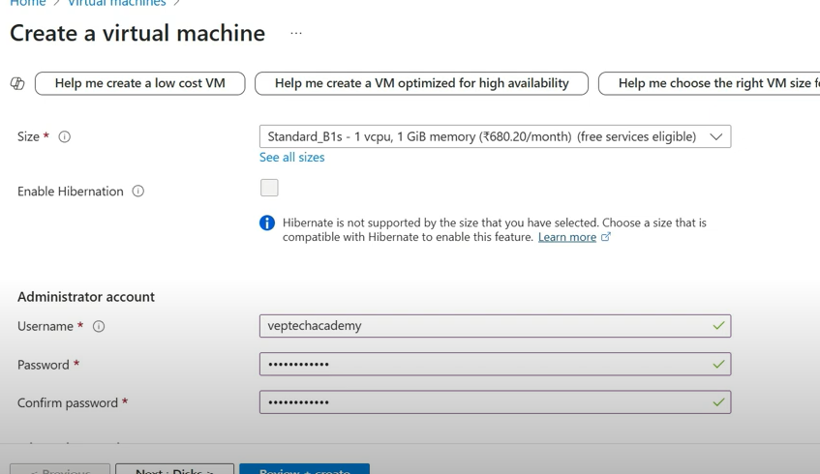

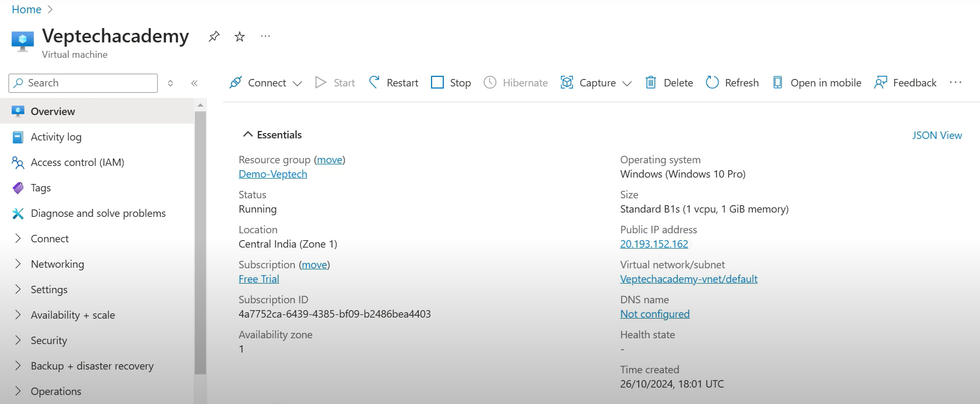

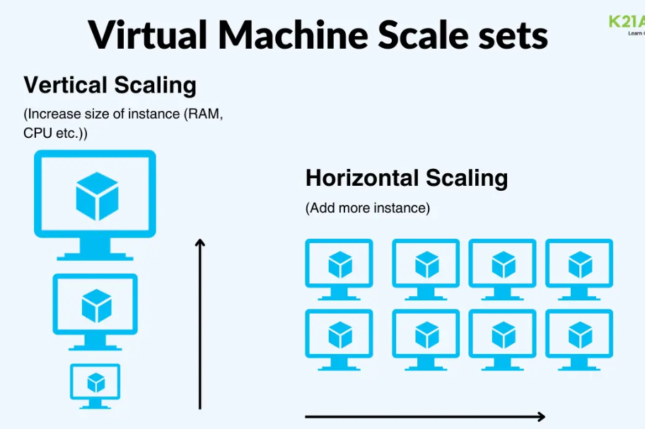

Type of VM:

General-purpose VMs:

* Balanced cpu-to-memory ratio.
* Ideal for web servers, small database, and development/testing.

Compute-optimized VMs:

* Higher cpu performance.
* Best for high-performance computing and batch processing.

Memory-optimized VMs:

* Higher memory-to-cpu ratio.
* Ideal for relational database, large caches, and in-memory analytics.

Storage-optimized VMs:

* High disk throughput and IOPS.
* Suited for big data, NoSQL databases, and data warehousing.

GPU-optimized vms:

* Equipped with GPUs for heavy graphics processing
* Best for AI, ML and 3D visualization.

High-performance computing VMs:

* Optimized for high-speed networking and low latency.
* Designed for scientific modelling, simulations.

Function app:

A function app in azure is a serverless compute service that lets you run small piece of code, called functions, “without needing to manage infrastructure. It automatically scales based on demand and you only pay for the resources used while the code is running. Great for event-driven task.

Azure Functions is a serverless computing service offered by Microsoft Azure.

App service:

* Azure App Service is a Platform-as-a-Service (PaaS) offering from Microsoft Azure that allows developers to quickly create, deploy and manage web, mobile and API apps.
* It provides a fully managed, highly scalable, secure, and reliable cloud-based environment for creating and running modern web, mobile, and API applications.
* With App Service, developers can quickly create and deploy applications to the cloud without having to worry about managing the underlying infrastructure.
* App Service also provides built-in features such as auto-scaling, backup, security, and encryption, making it an ideal platform for developing applications.
* Additionally, App Service provides an integrated development experience with Visual Studio, GitHub, and Azure DevOps, making it easy for developers to create and deploy applications in the cloud.

[You focus on development of applications without worrying about the infrastructure.]

(Is a platform that lets you easily build, host and scale web apps, apis or mobile backends, it supports different programming languages and handles task like security. Scaling and update, so you can focus on creating your app without worrying about managing server).

Azure App Service supports a variety of programming languages and frameworks, including.NET, Java, Node.js, and PHP, to meet a wide range of application development needs.

**Kubernetes service:**

AKS is a fully managed service that simplifies deploying, managing, and scaling containerized applications using Kubernetes.

Aks automates tasks like health monitoring, scaling and upgrades, allowing developers to focus on their applications.

It helps manage containers efficiently, making it easier to run complex applicates in the cloud.

**Azure Storage Service**

* **Blob Storage – storge any kind of data(like image, video)**
* **File Storage**
* **Tables - storge large amount of structured data.**
* **Queues**
* **Data Lake storage**
* **Data box**

**Blob Storage:**

Blob storage is a cloud service designed for storing large amounts of unstructured data, such as text, images and videos. It allows you to easily upload, manage, and access your data from anywhere in the world.

Blob storage is highly scalable, secure, and offers different tiers to optimize costs based on access frequency. With features like redundancy and automatic backups, it ensures data durability and availability.

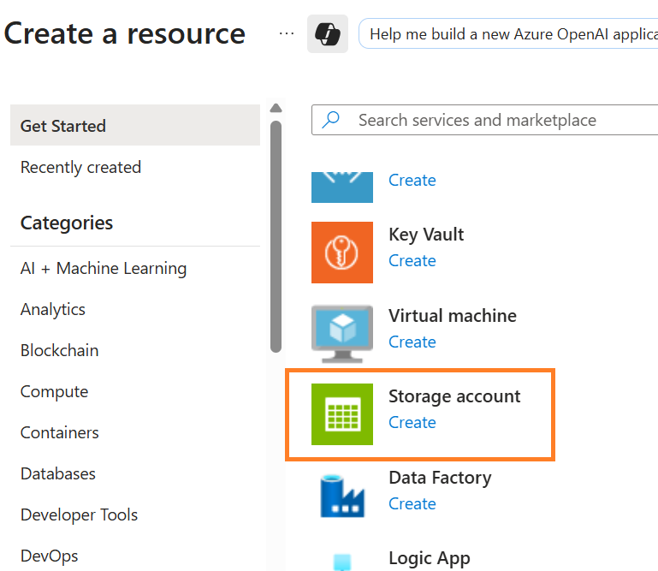

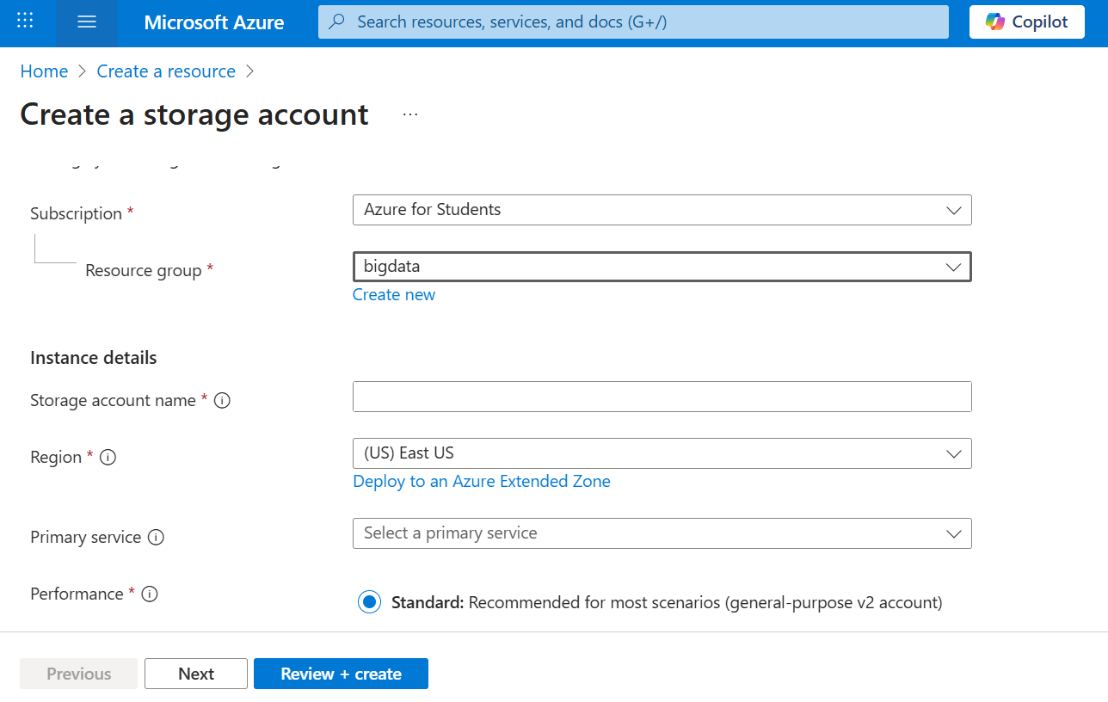

**Three types of Blobs:**

Block Blobs: Store text or binary files (videos, archives etc)

Append Blobs: Store log files (ideal for append operations)

Page blobs: foundation for azure disks (512-byte pages up to 8 TB)

**Azure Data Lake storage Gen2**: Azure Blob Storage Enhanced

* Designed for enterprise big data analytics.
* Low-cost, tiered storage, with hight availability/disaster recovery.

After created blob storage: If we want to upload

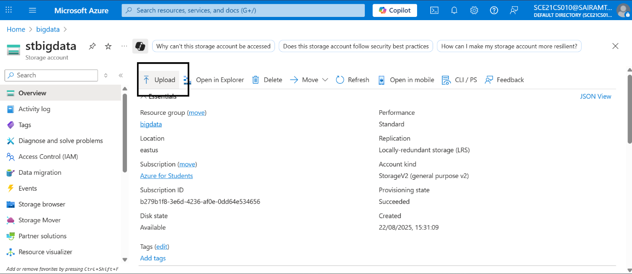

Create container:

Private – accessed only inside the azure portal

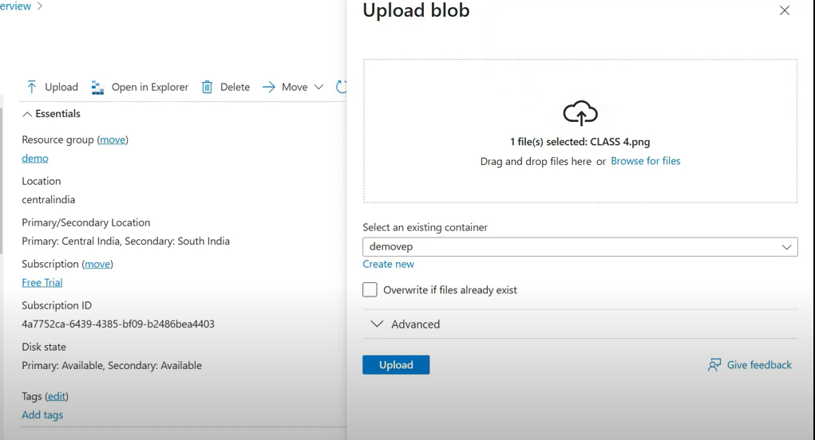

After uploaded file

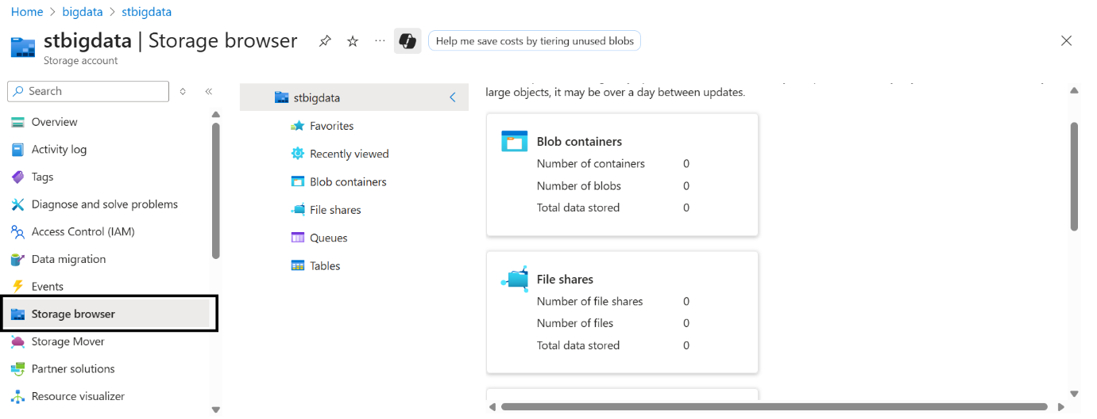

Inside demoevp

File Storage:

Is a managed file service in the cloud that allows you to store and access file using the SMB (server message block) protocol.

It enables seamless integration with on-premises applications and supports scenarios like lift-and-shift migrations and shared access. You can easily scale storage capacity and manage file shares through the Axure portal or REST APIs. Additionally, it offers features like snapshots and redundancy to ensure data protection and availability.

**Queues: (for processing some time need that time it struck in one line that is queue)**

Is a service that helps different parts of an app communicate by sending and receiving message in a queue.

It stores messages in line so that one part of an app can pick them up and process them later. This is useful for managing tasks that don’t need to be handled right away, making app run more smoothly.

**Data Lake Storage:**

For big data. It let you store massive amounts of structured, semi, unstructured data. With features like hierarchical file system and hight-performance access, it’s ideal for processing data from multiple sources.

This service helps organizations analyse data at scale, making it easier to gain insights and make data-driven decisions.

**Data Box:**

Azure Data Box is a physical device provided by Microsoft to help transfer large amounts of data to Azure when online transfers are too slow or costly. It comes in various sizes: data box (like 80TB or heavy 1PB).

After data is copied onto the device, it’s shipped back to Microsoft for uploading to zure. This is ideal for migrating large datasets or for backup solutions.

**Azure Key Vault**

The main purpose of using Azure key Vault in Microsoft Azure is to encrypt the data of any applications.

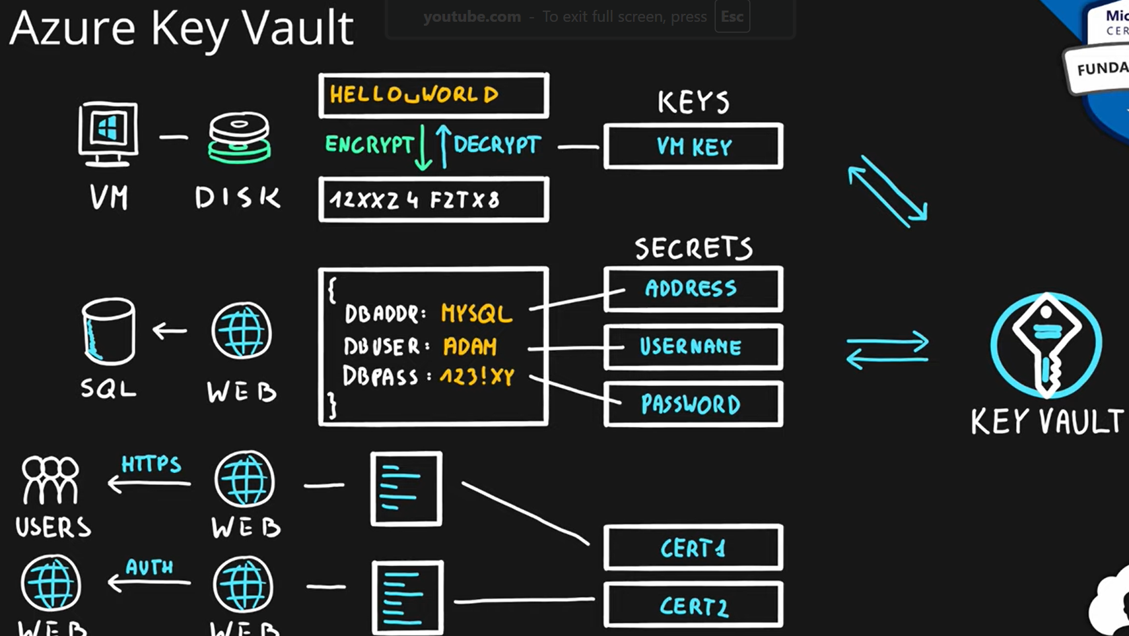

1. **Securely store secrets and keys:**

* Azure Key Vault is highly secure when it comes to data protection of applications such as keys and secrets.
* It is protected from users who don't have access to the vaults. and also it protects the other resources which are from Azure accessing the data of your application without sufficient permissions.

1. **Centralize application secrets:**

* Azure Key Vault will help you to manage the same data of different applications in a centralized manner where it makes easier for multiple applications to manage the data.

1. **Monitor:**

* You can monitor the data of the application which is encrypted also you can set up alerts based on the operations performed on the data.

1. **Scalability:**

* Azure Key vaults are highly scalable without human intervention. The Azure key vaults will be scaled depending on the data of the application size.

**The main purpose of the Azure key vault is to encrypt the data which is stored in Azure resource.**

1. Key Vault: The key vault in Azure is used to store the keys, secrets, and certificates provided are created by Microsoft Azure.
2. Key: With the help of keys, you are going to perform certain operations like encryption, decryption, and signing, and the keys are stored in the key vault.
3. Vault Owner: The owner of the vault will have all the control of the vaults he can manage the keys and secrets or certificates which are stored in that vault. He can perform the tasks like auditing and monitoring and some other tasks which are useful to the vault. You can Assign a Dedicated Key Vault Administrator Role to a User in Azure.
4. Certificates: You can store the certificates like SSL and TSL which are used for web applications.

**Features Of Azure Key Vaults**

* Highsecure
* Monitor and aduit
* Integrate with resource
* Restore and backup
* High availability

**Azure function**

* You write small pieces of code (called *functions*).
* They run only when triggered (event-driven).
* You don’t manage servers, scaling, or runtime — Azure handles it.
* You pay only for execution time (per ms and per execution).

Azure functions is a serverless computing service provided by azure to help us run tasks on a schedule like processing data, working with the IoT, and integrating systems.

There are many more integration and automation services that can be used to automate the process and define inputs, conditions, actions, and output.

Example use cases:

* Run a function when a file is uploaded to Blob Storage.
* Execute code when a queue/message arrives.
* Timer-based jobs.

**Azure Logic Apps**

A cloud service called Azure Logic Apps makes it easier to automate and orchestrate workflows, business processes, and tasks. It facilitates enterprise-wide app, data, system, and service integration by defining processes with a visual designer.

Azure Logic Apps is a cloud-based service from Microsoft designed to automate workflows and integrate applications, data, and systems across organizations with minimal coding required.

**What is Azure Logic Apps?**

Azure Logic Apps is part of Microsoft's App Service offering that provides a platform to develop, execute, and manage integrations for applications and data deployed in the cloud, on-premises, or both. It is designed to simplify and implement scalable integrations and workflows in the cloud.

**Comparison Table**

| **Feature** | **Azure Functions** | **Azure Logic Apps** |
| --- | --- | --- |
| **Purpose** | Execute custom code in response to events | Automate and orchestrate workflows |
| **Development Approach** | Requires coding | No/low code visual designer |
| **Execution Model** | Event-driven | Workflow-driven |
| **Use Cases** | Microservices, background tasks, data processing | Business process automation, data integration |
| **Integration** | Limited built-in connectors | Extensive library of connectors |
| **Pricing** | Based on execution time and number of executions | Based on number of actions in the workflow |
| **Best For** | Developers | Business analysts, IT pros |

**Microsoft Azure SQL Database**

**Azure SQL Database**is a relational database (RDBMS) service provided by **Microsoft Azure** that is widely used by developers when creating new applications in the cloud.

It is managed completely by Microsoft and is a highly scalable platform-as-a-service (PaaS) designed especially for cloud applications.

It offers a managed environment, handling tasks like backups and security. Users can create databases, organize data into tables, and run queries.

The server is a logical construct that acts as the central administration point for pooled databases or multiple logins, auditing rules, threat detection policy, and failover groups.

**Azure SQL vs. SQL Server**

| **Feature** | **Azure SQL Database** | **SQL Server** |
| --- | --- | --- |
| Deployment | Cloud-based, managed by Microsoft | Typically on-premises or in private data centers |
| Management | Managed service, Microsoft handles maintenance | Requires self-management, updates, and backups |
| Scalability | Easily scalable, with options for auto-scaling | Scalability is limited by hardware and resources |
| Availability | High availability with built-in redundancy | Availability depends on local infrastructure |
| Cost | Pay-as-you-go pricing model | Requires upfront investment and ongoing costs |
| Maintenance | Microsoft handles updates, patches, and backups | Requires manual management and administration |
| Security | Built-in security features, compliance options | Security configuration managed by the user |